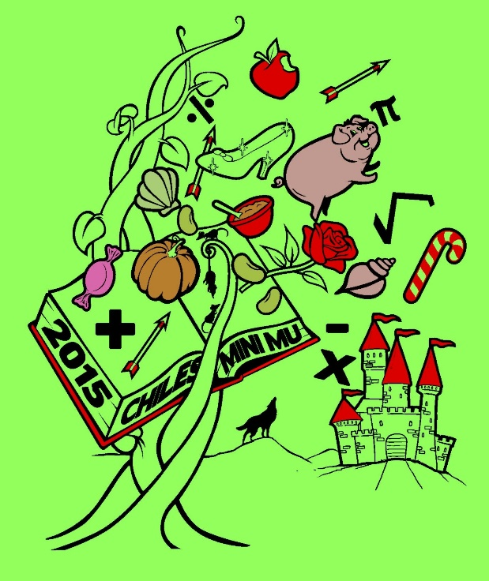

**2015**

**CHILES MINI MU**

**12 December 2015**

**Lawton Chiles High School**

**Hosted by Chiles Mu Alpha**

**Theta**

**ALGEBRA I**

**SESSION 1**

**HANSEL and GRETEL**

Once upon a time, there was an evil witch who liked to eat children. Though she had been a witch for many years and loved eating children, she also had another passion: mathematics. So, she took up a part time job as a math teacher in an underprivileged witch sch**o**ol in the middle of the woods. This is one of her math tests from years ago. Have a ‘fairy’ good time, and good luck!

